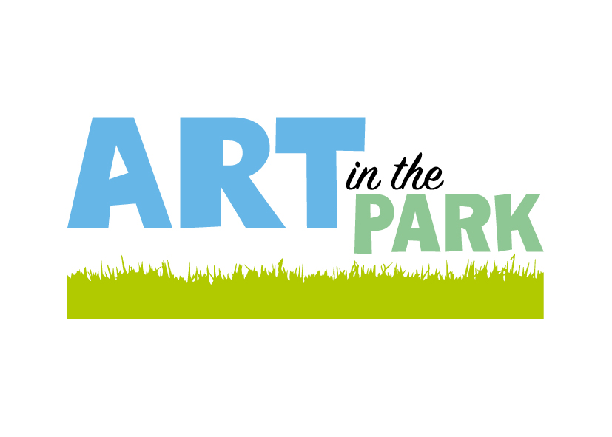

Information for Registering Artists
Limited outdoor sites are available. • You will be required to provide your own tables. Chairs will be provided. • Tables, easels or display stands must ensure they do not infringe on foot traffic or adjacent stalls. NB - note single site area boundaries will be enforced. • Please note: due to OSH restrictions, any fabric used to cover stalls or used in display MUST be fire resistant such as natural fibres (wool, cotton etc.) Poly cotton, polyester or anything man made are not permissible. • Power points can be provided for those who order them at no charge. Any leads or electrical equipment you bring must have a current certificate of fitness. • There will be a debrief questionnaire for exhibiting artists in which we may try to collect some statistical information on AiTP to improve our event, including age and ethnicity of our artists. We hope you feel able to assist us with these data requests. • We like to put artist bios on the website. If you would like to send one to our email address (no more than 100 words, preferably send as a word document or a PDF) and attach separately 1 or 2 photos of an acceptable resolution, we will put them onto the website: www.artinthepark.nz also check out our FB: Art in the Park Greymouth Refunds - Please Note: Up until 28 February you are entitled to a full refund less a $10 admi

eder52@me.com

www.artinthepark.nz

FB: artintheparkgreymouth

021980088

The Art in the Park venue for 2026 will be at the Greymouth High School Gymnasium, High Street Greymouth. Please read the information carefully before completing the registration form.

- Art in the Park is a two day event open to the public on Saturday 10am to 4pm and Sunday 10am to 3pm.
- All work must be original and be for sale. It must include works not previously exhibited at the event.
- You must attend or have your site manned on both days. There is no one day option.
- Set up time is 3pm to 7pm Friday and 8.00am - 9.30am on Saturday.
- Indoor display panels are approximately 2.4m x 1.2m (1 panel - most artists take 2 panels)).
- One or two panels only are available per artist.(see Registration form for details of pricing).
- Limited outdoor sites are available.
- You will be required to provide your own tables. Chairs will be provided.
- Tables, easels or display stands must ensure they do not infringe on foot traffic or adjacent stalls. NB - note single site area boundaries will be enforced.
- Please note: due to OSH restrictions, any fabric used to cover stalls or used in display MUST be fire resistant such as natural fibres (wool, cotton etc.) Poly cotton, polyester or anything man made are not permissible.
- Power points can be provided for those who order them at no charge. Any leads or electrical equipment you bring must have a current certificate of fitness.
- There will be a debrief questionnaire for exhibiting artists in which we may try to collect some statistical information on AiTP to improve our event, including age and ethnicity of our artists. We hope you feel able to assist us with these data requests.

- We like to put artist bios on the website. If you would like to send one to our email address (no more than 100 words, preferably send as a word document or a PDF) and attach separately 1 or 2 photos of an acceptable resolution, we will put them onto the website: www.artinthepark.nz also check out our FB: Art in the Park Greymouth

Refunds - Please Note:
Up until 28 February you are entitled to a full refund less a $10 admin fee should you wish to withdraw from the event.
There will be a 50% refund on any withdrawals from 28 February to 31 March.
After 31 March there will be no refund.
Unsuccessful applications will be refunded in full.

